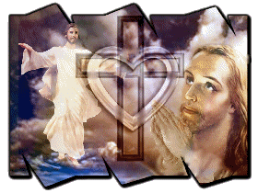

***Global Revival Network***

**This is to certify that**

**Insert Person’s Name Here**

**Is a full and active Member in the Global Revival Network, a world-wide Christian organization dedicated to bringing**

**the Body of Christ across the globe together in fervent, effectual prayer for the purpose of bringing true revival to the**

**Church, cleansing, purifying and restoring Her to complete personal sanctification and holiness, filling Her with both**

**the Personality and the Power of Her Lord and Savior Jesus Christ and helping the Bride to finally make Herself ready**

**so that She can attain to the measure of the stature of the fullness of Christ Himself, according to Ephesians 4:13.**



**In becoming a Member of the Global Revival network, this individual commits themselves to helping to expand the**

**Network so that others can share in the blessings which the Lord bestows upon His People when they make**

**themselves into a fit vessel, capable of every good work (II Timothy 2:21), walking in faith, hope and love.**

____________________ __________________________________ **Dr. Raymond L. Young**

**Ugandan Coordinator Acting African Continental Coordinator Global Coordinator**