

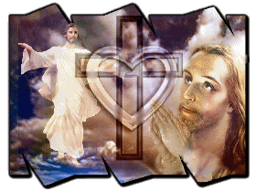

Global Revival Network
This is to certify that

Insert Person’s Name Here
Is a full and active Member in the Global Revival Network, a world-wide Christian organization dedicated to bringing
the Body of Christ across the globe together in fervent, effectual prayer for the purpose of bringing true revival to the
Church, cleansing, purifying and restoring Her to complete personal sanctification and holiness, filling Her with both
the Personality and the Power of Her Lord and Savior Jesus Christ and helping the Bride to finally make Herself ready
so that She can attain to the measure of the stature of the fullness of Christ Himself, according to Ephesians 4:13.


In becoming a Member of the Global Revival network, this individual commits themselves to helping to expand the
Network so that others can share in the blessings which the Lord bestows upon His People when they make
themselves into a fit vessel, capable of every good work (II Timothy 2:21), walking in faith, hope and love.

____________________ __________________________________ Dr. Raymond L. Young
National Coordinator Continental Coordinator Global Coordinator

